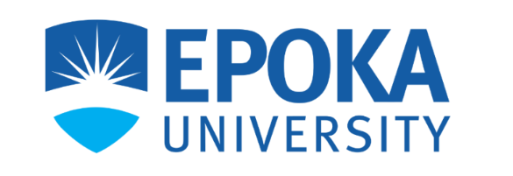

MEETING REPORT
WEEK 1

Team Name: Undergraduate Lab Portal
Date of Meeting: 07/03/2026
Start Time: 11 AM
End Time: 12 AM
Meeting Location: Epoka Univesity
Moderator: Sibora Kociu
Recorder: Redi Cuka

Other Members Present: Nikol Isaku, Arbiana Muka, Megi Sollaku, Arlind Disha, Arli Asllani

Members Absent: -
Topics Discussed:
This week we finalized the general idea and workflow of our project by defining four different actors: Students, Admins, Professors, and the External Programs & Partnerships Department.
We also discussed their user stories and the main functionalities for each actor. The user roles and features were divided among all team members. The group members defined the main goals for each actor as follows:
Students – Main goal: Help students find and apply for research opportunities and build a research profile.
Professors – Main goal: Manage research projects and recruit students.
Admin (Department Level) – Main goal: Oversight, reporting, and funding management.
External Programs & Partnerships Office – Main goal: Manage international and external opportunities.
Progress Report:
- Sibora Kociu + Redi Cuka: Took responsibility for the Professor user role and created a general idea of the user stories and how the professor’s functionality in the portal will work.
- Arlind Disha + Arli Asllani: Worked on the Admin user role and created a general idea of the user stories and system functionalities for this role.
- Nikol Isaku + Arbiana Muka + Megi Sollaku: Worked on the Student role and the External Programs & Partnerships Office role, defining user stories and main functionalities.

Conclusion:
This week we successfully defined the main idea, system actors, and their responsibilities. The team divided the roles and started working on user stories and system functionalities for each actor.
Top of Form

Bottom of Form

